# DBMS-2006 Final Project Milestone One Project Proposal

**Developer Name:** Lashman Singh

**Project Name:** Lashman’s Music Production Team (LMPT)

**Date:** March 31, 2023

1. **Project description:**

This database will include all elements of a music production team. It will include tables related to music team such as songs, album, singers, genre, directors, and a few more.

As a singer with a melodious voice, I'm excited to work on the LMPT project. Music is universally loved and brings people together, regardless of their tastes. It's not only about listening to music, but also about connecting with the lyrics and stories behind the songs. This project allows me to explore the magic of music, and studying my interest in it would be fun.

1. **Business Case:**

In recent times, there's been a growing trend of people enjoying diverse music genres, including those from different countries. This has led singers, directors, and songwriters to collaborate on creating songs, with producers stepping in to initiate production and distribution. Given the widespread appeal of such music across various age groups and regions worldwide, the target audience for these songs spans all demographics.

1. **Business Rules/Assumptions:**

* The singers may have one band.
* The director who directs the song may have directed one or many albums.
* The producer who helps financially makes the process of making song starts may produce one or many albums.
* The Album may have one or many songs.
* The album can be created by one or many bands collaborating from different regions and cultures.
* The Band may have one or many singers.
* The Band should have at least one or many genres.

1. **Entity Relationship Diagram:**

Using draw.io, create the ERD diagram. Be sure to include meaningful.

field names and that your PK’s and FKs identified. Remember every table needs a primary key and every relationship line needs a verb describing the relationship line. Paste a screenshot below.

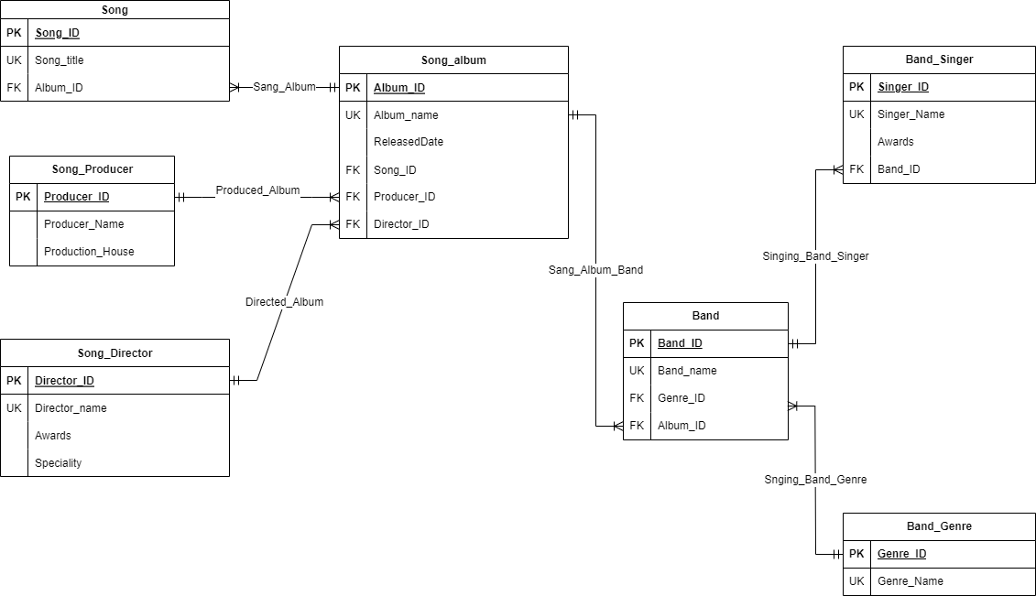

When you review the ERD with your instructor you will be asked the following. Open the ERD in the program you created it in.

* + - Describe each entity and how they relate to each other in both directions.
    - Describe the symbols used on each line.
    - If there were any bridge or joiner tables created
    - Explain why the table was created.
    - Explain what PK was created for the joiner/bridge table and what makes it a good primary key.
    - Explain FKs in the bridge table and their purpose.

**NOTE:** Students are not permitted to have a project based on an academic environment *(students, courses, books, instructors....)*. Project must be unique and cannot be anything that was used in this or previous courses.